Yes. This is a very good AWS networking lab because AWS VPC peering does not support overlapping CIDR ranges, so we can deliberately build two VPCs in different regions with the same CIDR and then test what works and what fails.
AWS Lab Plan — Same CIDR Across Two Regions
Objective
Create:
AWS Region 1 AWS Region 2
(e.g. Mumbai) (e.g. Singapore)

VPC-Region1 VPC-Region2
10.100.0.0/16 10.100.0.0/16
| |
EC2-1 EC2-2
10.100.1.10 10.100.1.10
Then test:
- VPC Peering
- Transit Gateway
- Private IP connectivity
- Route tables
- Security Groups
- NAT Gateway
- Possible workarounds for overlapping CIDRs

Phase 1 — Build the two VPCs
I'll use:
Component | Region 1 | Region 2
Region | ap-south-1 Mumbai | ap-southeast-1 Singapore
VPC | VPC-R1 | VPC-R2
CIDR | 10.100.0.0/16 | 10.100.0.0/16
Public subnet | 10.100.1.0/24 | 10.100.1.0/24
Private subnet | 10.100.2.0/24 | 10.100.2.0/24
EC2 | Linux | Linux
The important part is:
VPC-R1 = 10.100.0.0/16
VPC-R2 = 10.100.0.0/16
They intentionally overlap 100%.

Region 1 – Hydrabad:
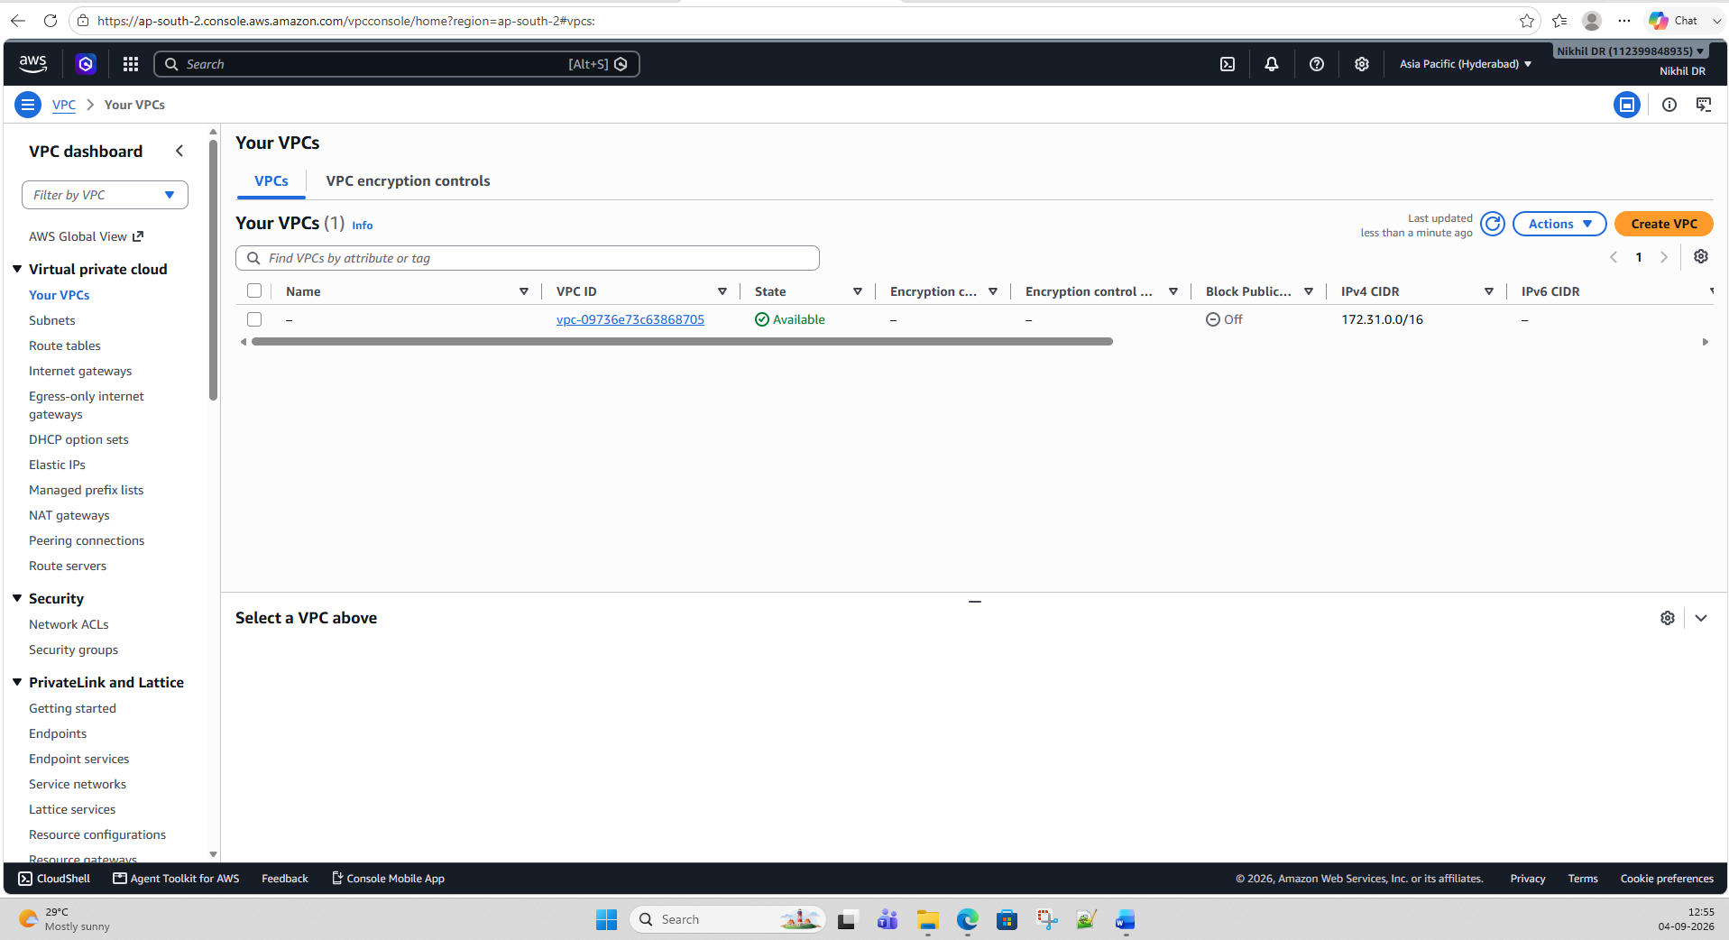
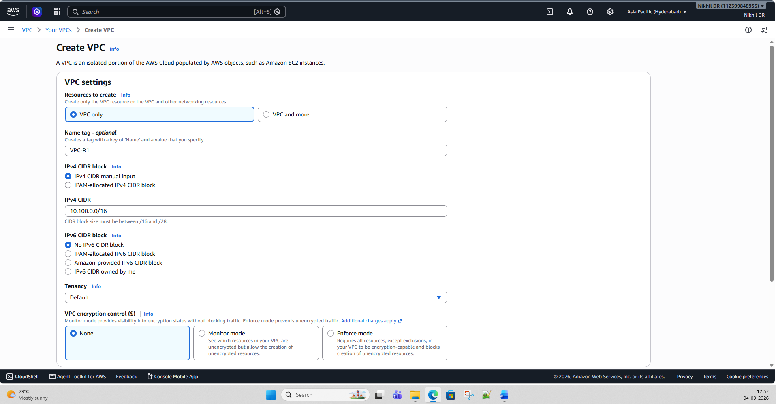
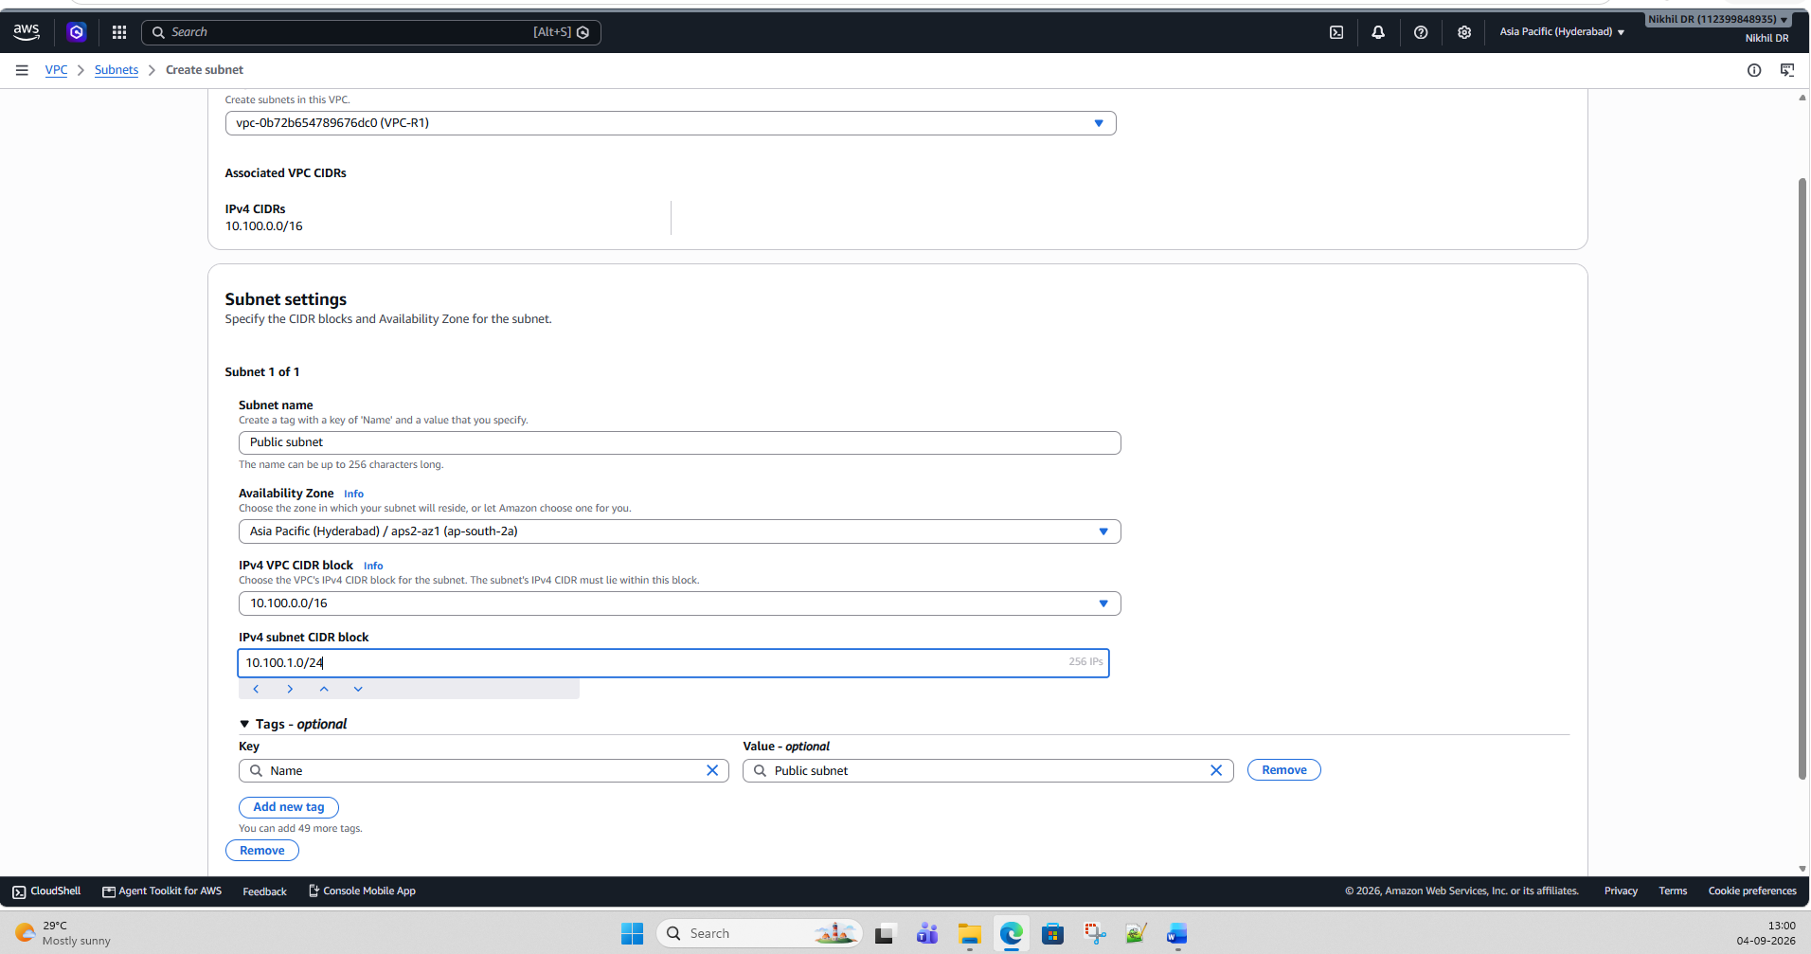
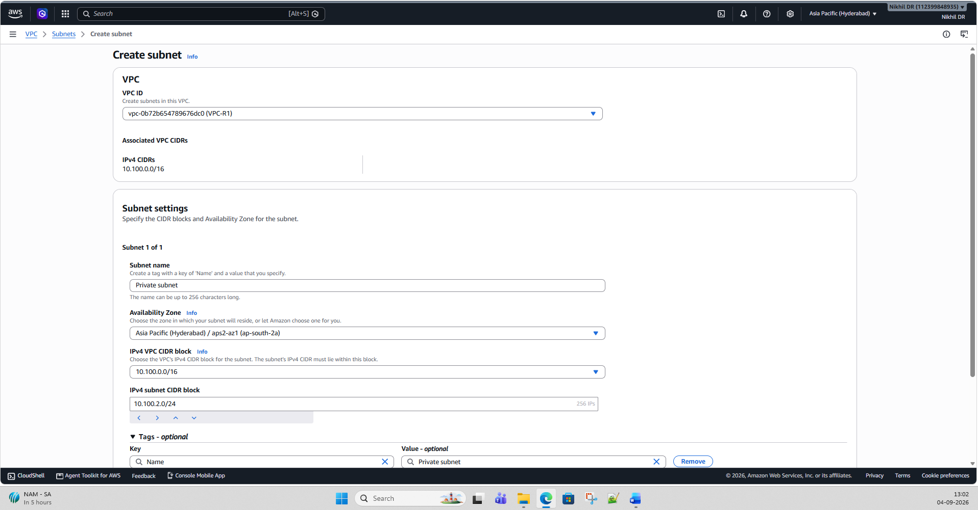

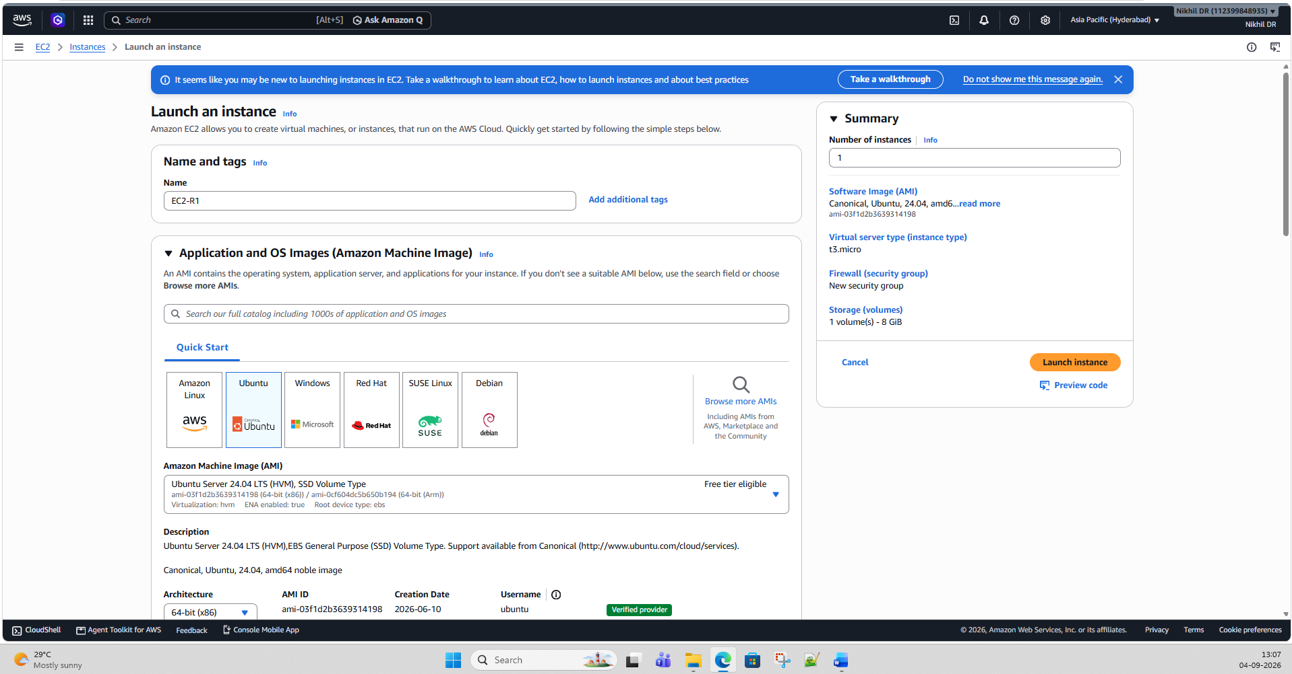

Region 2: Mumbai
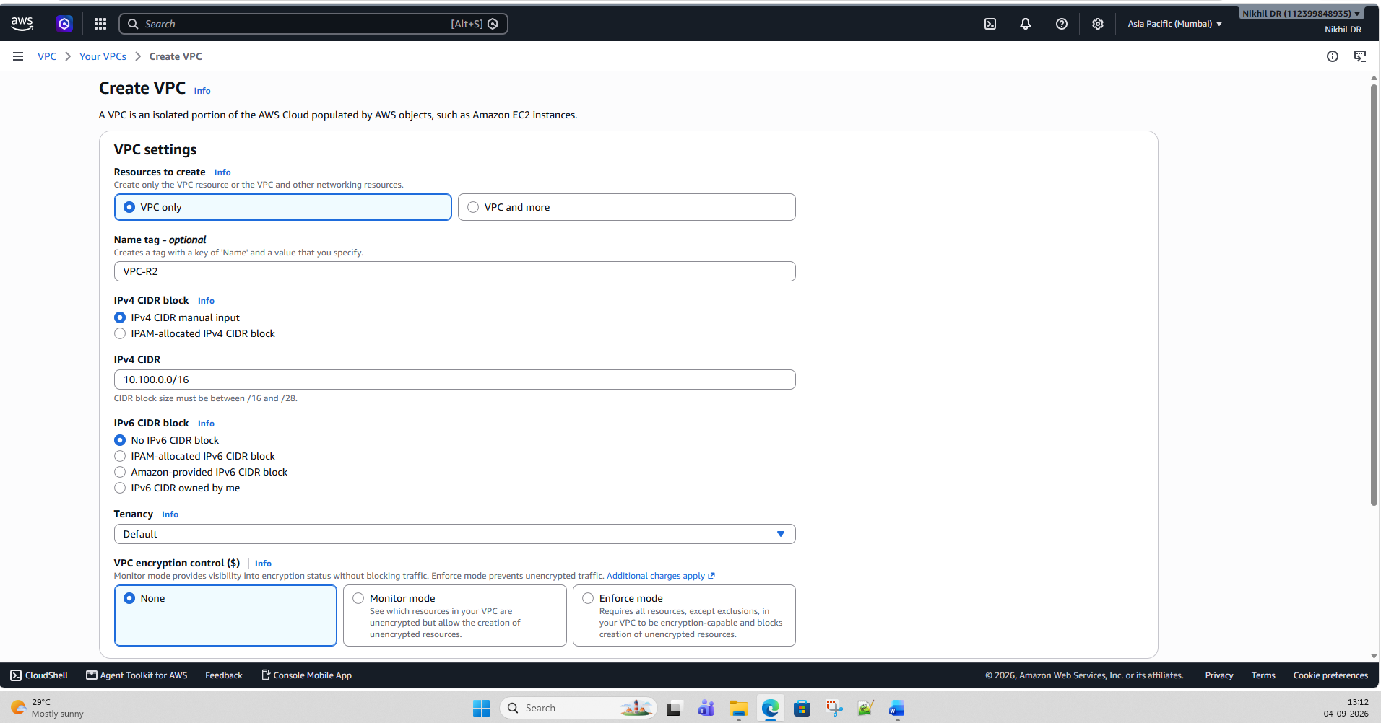

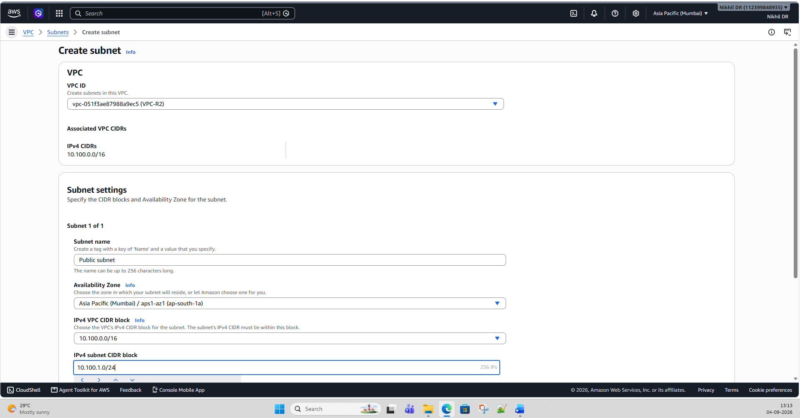

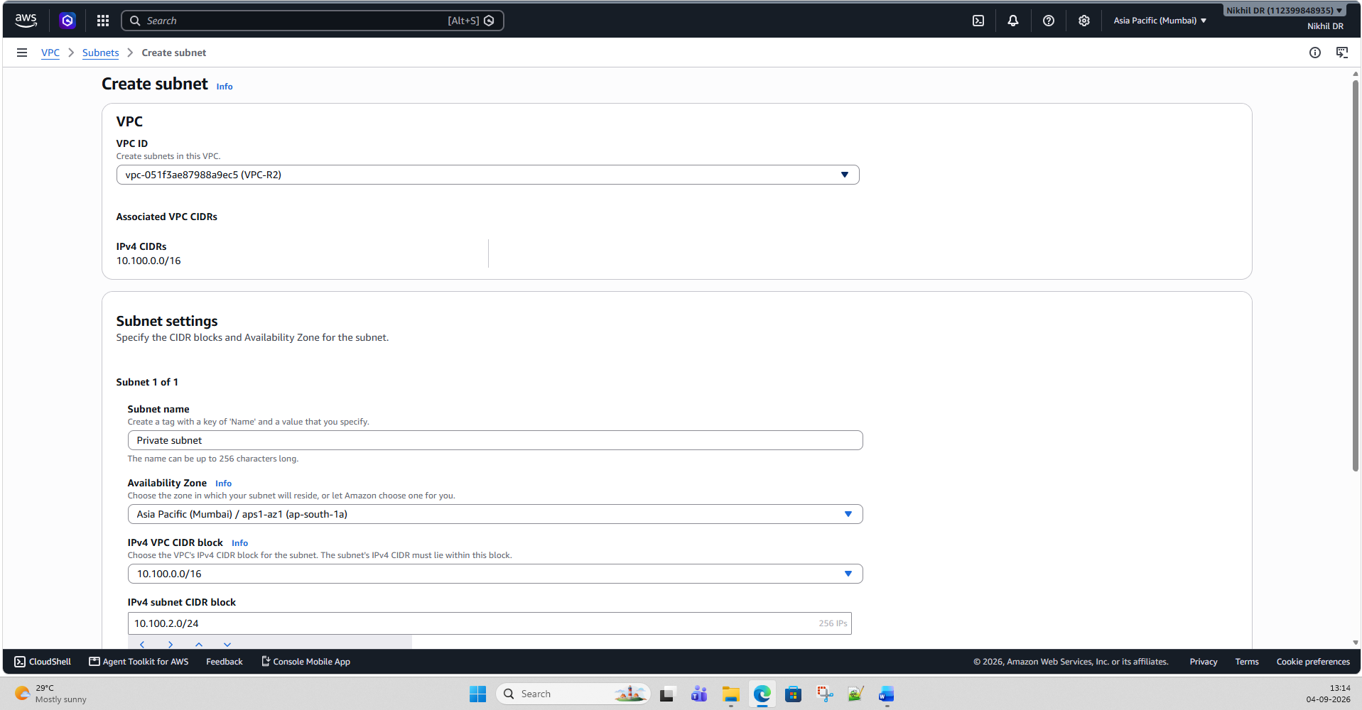
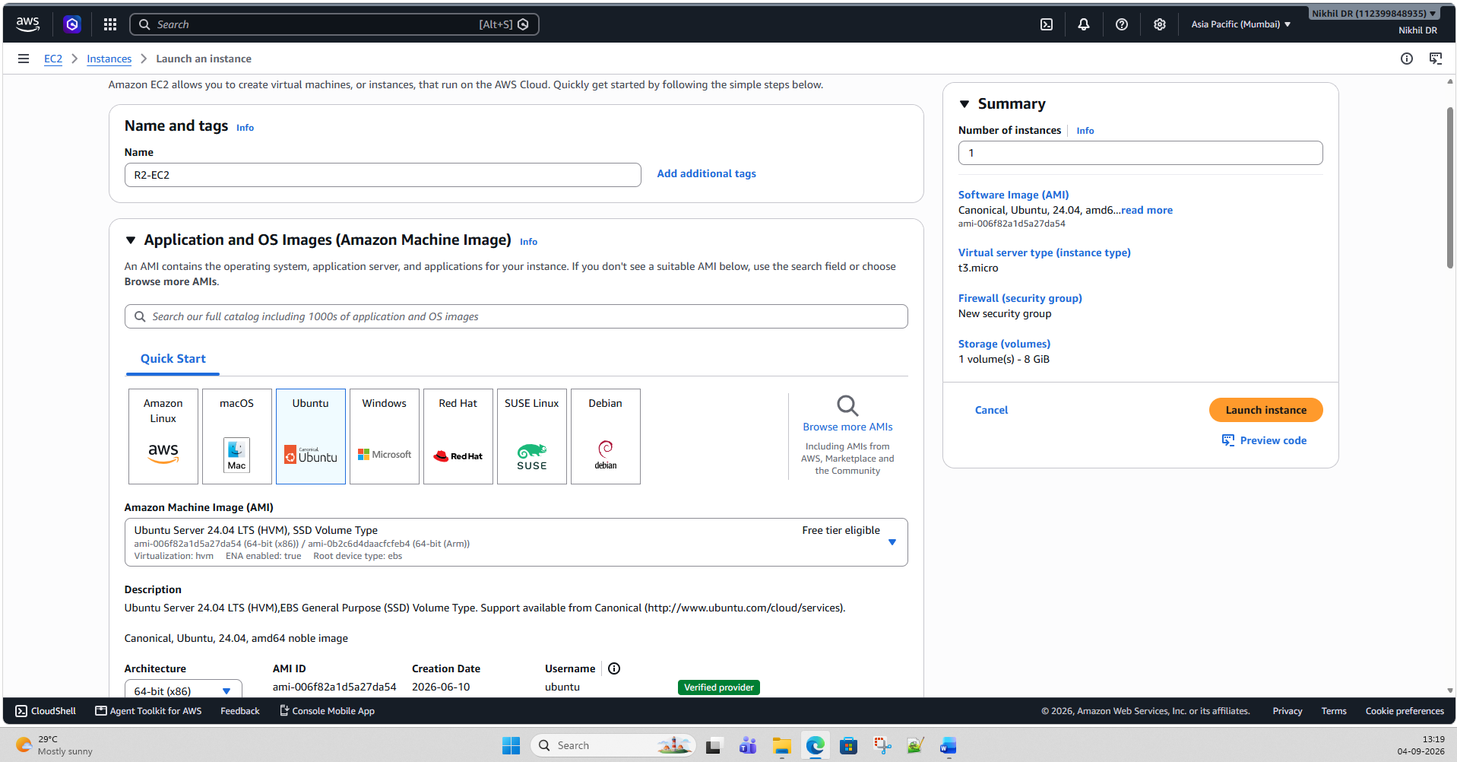

Yes. Let's build Phase 2 exactly as a hands-on AWS Console lab.
One small correction to the earlier wording: because you're testing Internet connectivity, you don't actually need the two regions to communicate with each other privately yet. Each EC2 will independently reach the Internet through its own VPC's Internet Gateway. Later, we'll test private connectivity between the VPCs.
AWS confirms that a subnet is public when its route table has a route such as 0.0.0.0/0 → Internet Gateway, and an EC2 instance needs a public IPv4 address for IPv4 Internet communication. (AWS Documentation)
Phase 2 — Detailed Lab
We'll create:
REGION 1
Mumbai
ap-south-1

Internet
|
Internet Gateway
|
VPC-R1: 10.100.0.0/16
|
Public Subnet
10.100.1.0/24
|
EC2-R1
10.100.1.x
Public IP

REGION 2
Singapore
ap-southeast-1

Internet
|
Internet Gateway
|
VPC-R2: 10.100.0.0/16
|
Public Subnet
10.100.1.0/24
|
EC2-R2
10.100.1.x
Public IP
Notice that both VPCs intentionally use the same CIDR.

Step 1 — Create VPC-R1 in Mumbai
Go to the AWS Console and change the Region to:
Asia Pacific (Mumbai) — ap-south-1
Open:
VPC → Your VPCs → Create VPC
Choose:
Resources to create:
VPC only
Enter:
Field | Value
Name tag | VPC-R1
IPv4 CIDR | 10.100.0.0/16
IPv6 CIDR | No IPv6
Tenancy | Default
Click:
Create VPC
You now have:
VPC-R1
10.100.0.0/16

Step 2 — Create the subnet
Go to:
VPC → Subnets → Create subnet
Select:
VPC: VPC-R1
Choose an Availability Zone, for example:
ap-south-1a
Enter:
Field | Value
Subnet name | R1-Public-Subnet
IPv4 subnet CIDR | 10.100.1.0/24
Click:
Create subnet
You now have:
VPC-R1
10.100.0.0/16
|
+-- R1-Public-Subnet
10.100.1.0/24

Step 3 — Create Internet Gateway
Go to:
VPC → Internet gateways
Click:
Create internet gateway
Name:
IGW-R1
Click:
Create internet gateway
Now select IGW-R1.
Choose:
Actions → Attach to a VPC
Select:
VPC-R1
Click:
Attach internet gateway
Your architecture is now:
Internet
|
IGW-R1
|
VPC-R1
An Internet Gateway must be attached to the VPC before it can provide Internet connectivity. (AWS Documentation)

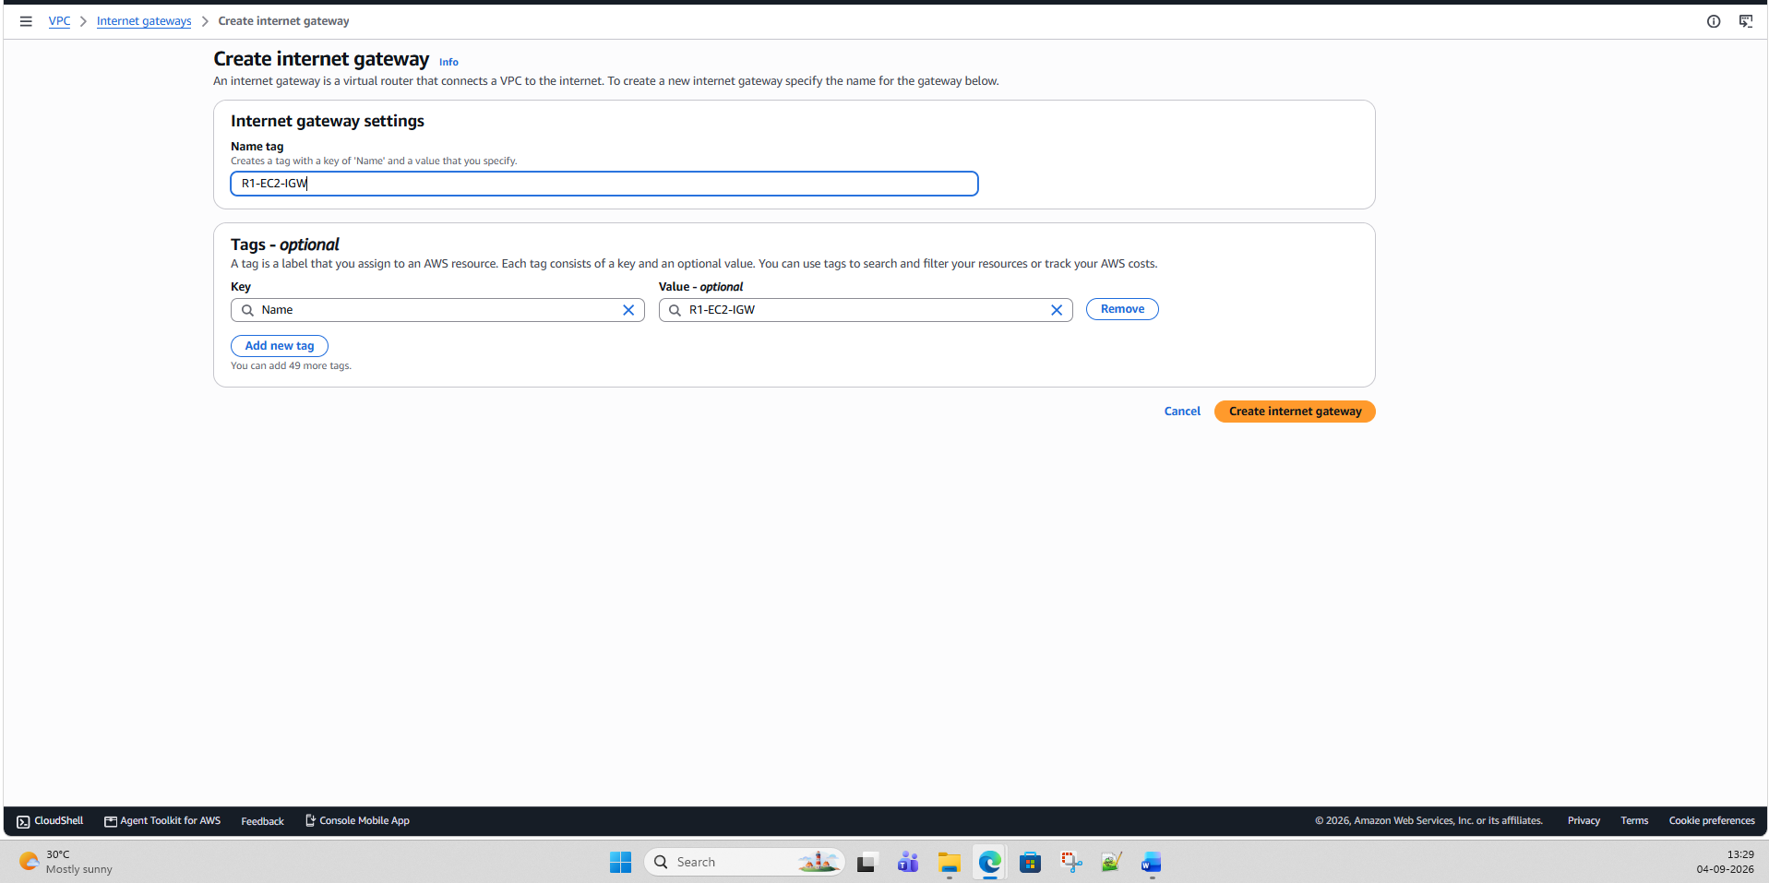

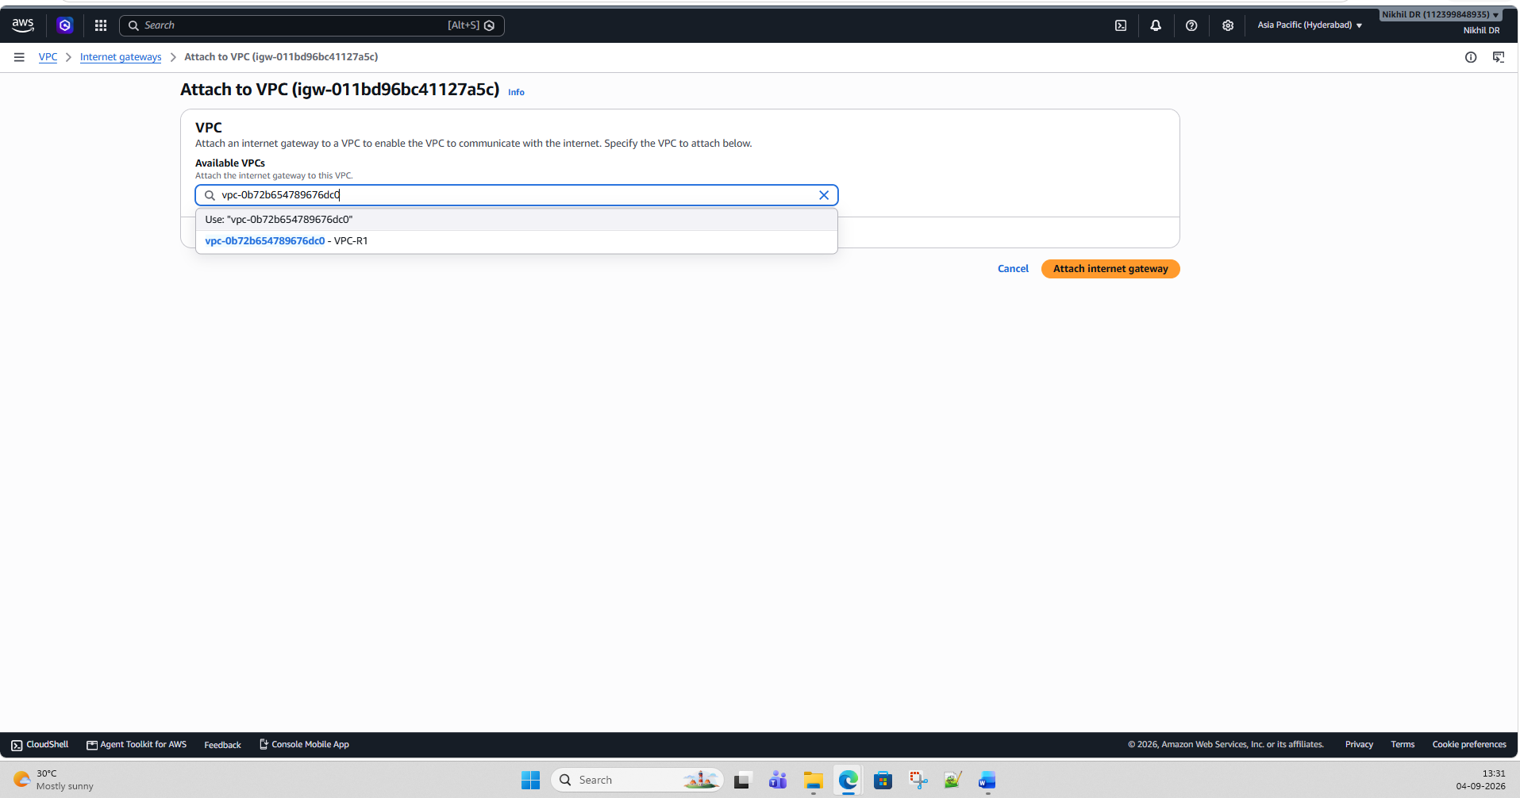

Step 4 — Create a Route Table
Go to:
VPC → Route tables → Create route table
Enter:
Field | Value
Name | R1-Public-RT
VPC | VPC-R1
Click:
Create route table

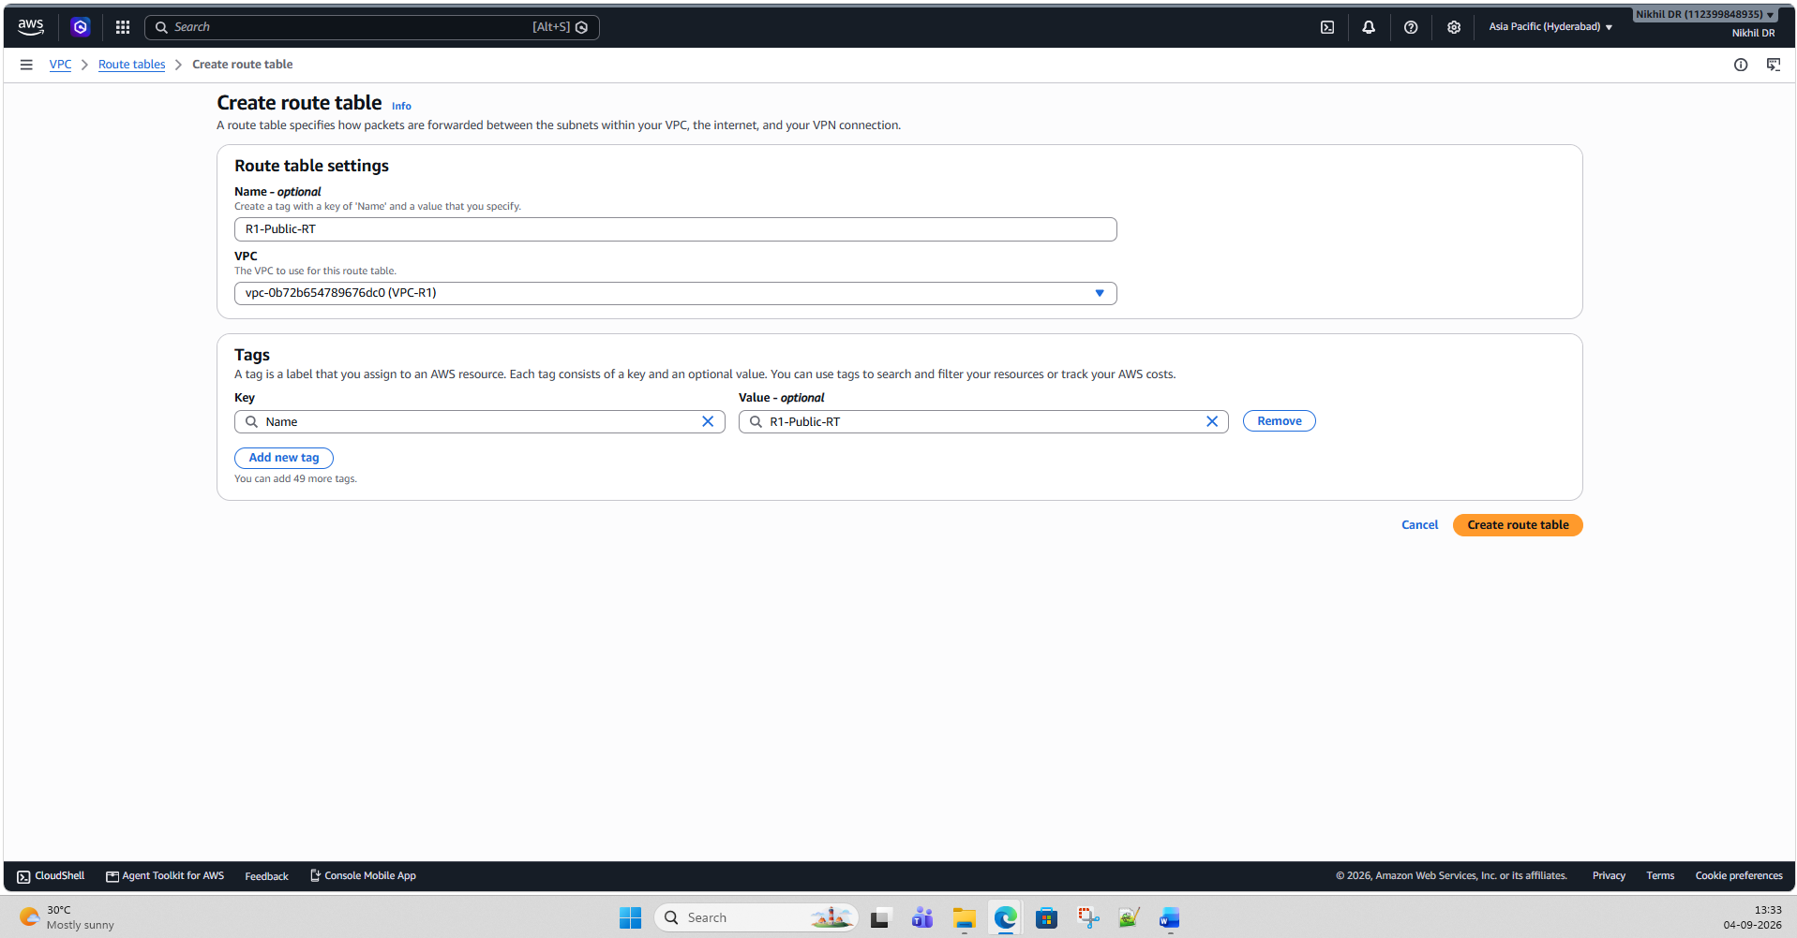

Step 5 — Add Internet route
Select:
R1-Public-RT
Go to:
Routes → Edit routes → Add route
Enter:
Destination: 0.0.0.0/0
Target: Internet Gateway
IGW-R1
Click:
Save changes
Your route table should now look approximately like:
Destination | Target
10.100.0.0/16 | Local
0.0.0.0/0 | IGW-R1
The local route is automatically created for communication inside the VPC; the 0.0.0.0/0 → IGW route sends other IPv4 traffic toward the Internet Gateway. (AWS Documentation)

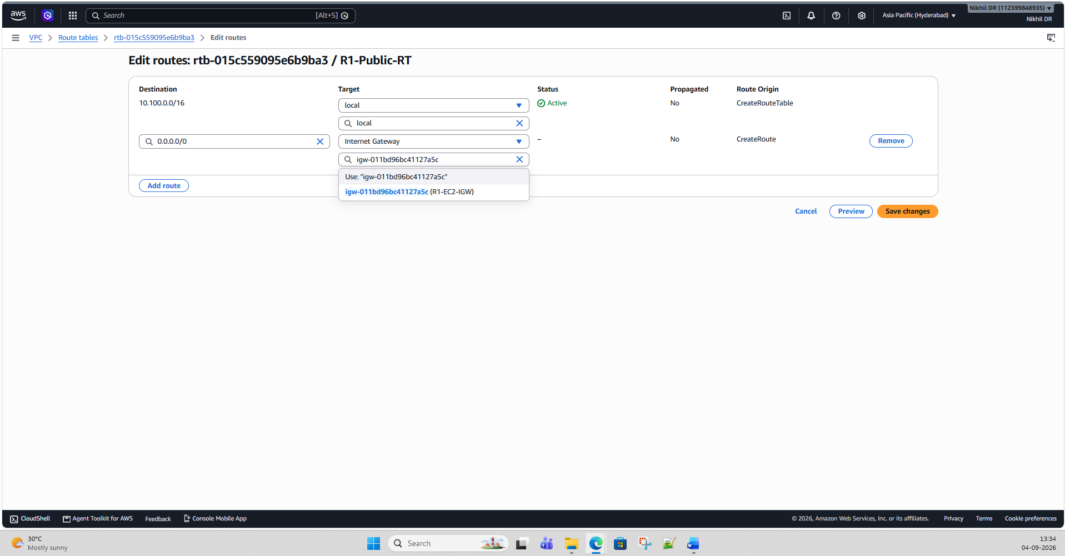

Step 6 — Associate the route table with the subnet
Still inside:
R1-Public-RT
Go to:
Subnet associations → Edit subnet associations
Select:
R1-Public-Subnet
Click:
Save associations
Now:
R1-Public-Subnet
|
v
R1-Public-RT
|
| 0.0.0.0/0
v
IGW-R1
|
v
Internet

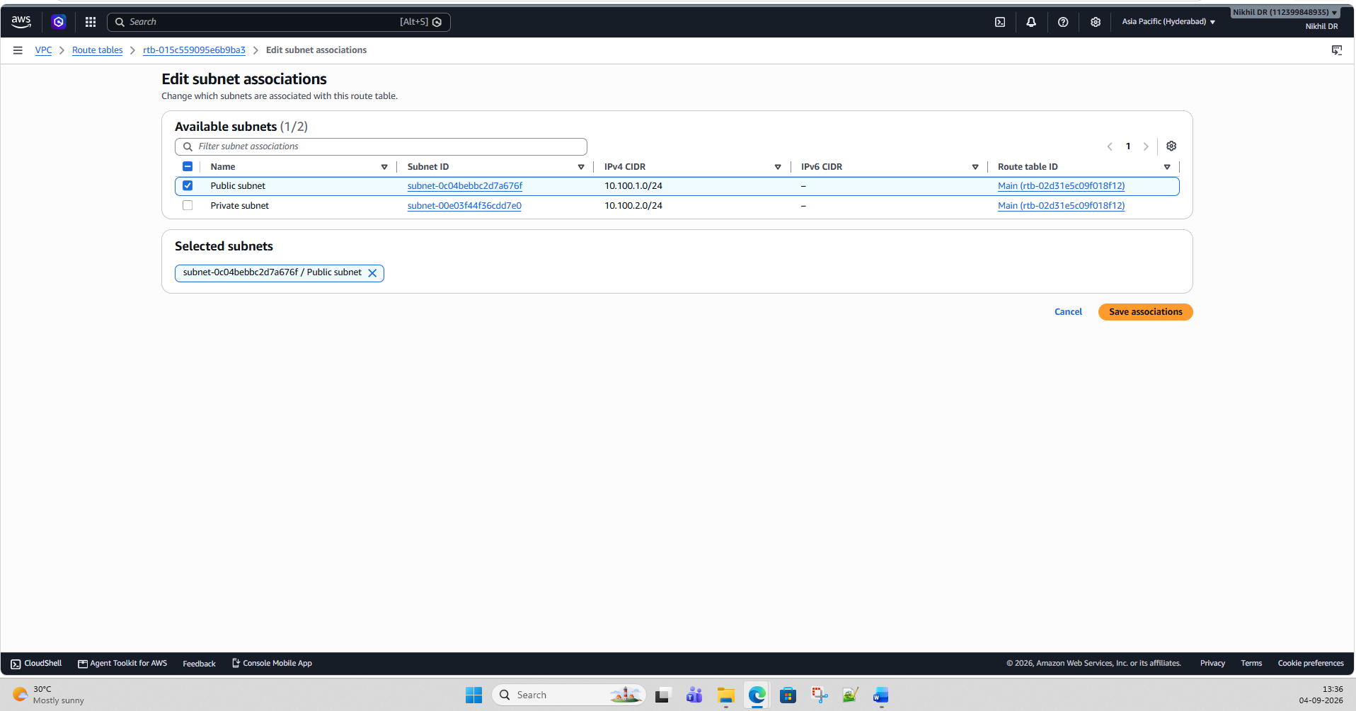

Step 7 — Enable automatic Public IP
Go to:
VPC → Subnets
Select:
R1-Public-Subnet
Choose:
Actions → Edit subnet settings
Enable:
Enable auto-assign public IPv4 address
Save.
This means new EC2 network interfaces launched into this subnet can automatically receive public IPv4 addresses.

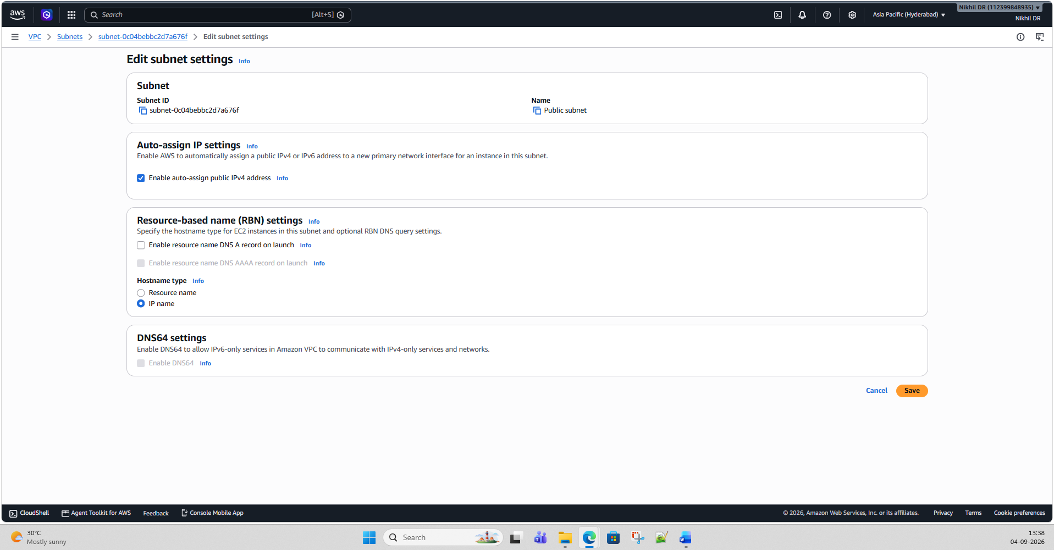

Step 8 — Create Security Group
Go to:
EC2 → Security Groups → Create security group
Enter:
Field | Value
Security group name | R1-EC2-SG
Description | Security group for R1 test EC2
VPC | VPC-R1
Inbound rules
For SSH:
Type: SSH
Protocol: TCP
Port: 22
Source: My IP
This is better than allowing SSH from 0.0.0.0/0.
For our later connectivity testing, you can also temporarily add:
Type: ICMP - IPv4 Echo Request
Source: 0.0.0.0/0
Important: ICMP/ping is not automatically allowed just because SSH is allowed. Security groups control which traffic reaches the instance. (AWS Documentation)
For a short lab, you can remove the ICMP rule later.

Step 9 — Launch EC2-R1
Go to:
EC2 → Instances → Launch instance
Name:
EC2-R1
Choose a Linux AMI available in your account/region.
For example, Amazon Linux.
Choose a small instance type appropriate for your lab.
Under Network settings, select:
VPC: VPC-R1
Subnet: R1-Public-Subnet
Auto-assign Public IP: Enable
Security Group: R1-EC2-SG
Choose/create your key pair.
Then:
Launch instance
Wait until:
Instance state: Running
Status checks: 2/2 checks passed

Step 10 — Verify EC2-R1
Click your instance.
You should see something similar to:
Private IPv4 address:
10.100.1.25

Public IPv4 address:
3.x.x.x
The exact addresses will be different.
Your first environment is now:
Internet
|
IGW-R1
|
10.100.0.0/16
VPC-R1
|
10.100.1.0/24
|
EC2-R1
10.100.1.25
Public IP

Step 11 — SSH to EC2-R1
From your computer:
ssh -i your-key.pem ec2-user@<R1-PUBLIC-IP>
For Ubuntu, the username is usually:
ubuntu
For Amazon Linux, typically:
ec2-user
Once logged in:
ping -c 4 8.8.8.8
You should get replies if ICMP to that destination is available.
Also test DNS:
nslookup amazon.com
or:
curl https://example.com
If these work, R1 Internet connectivity is confirmed.

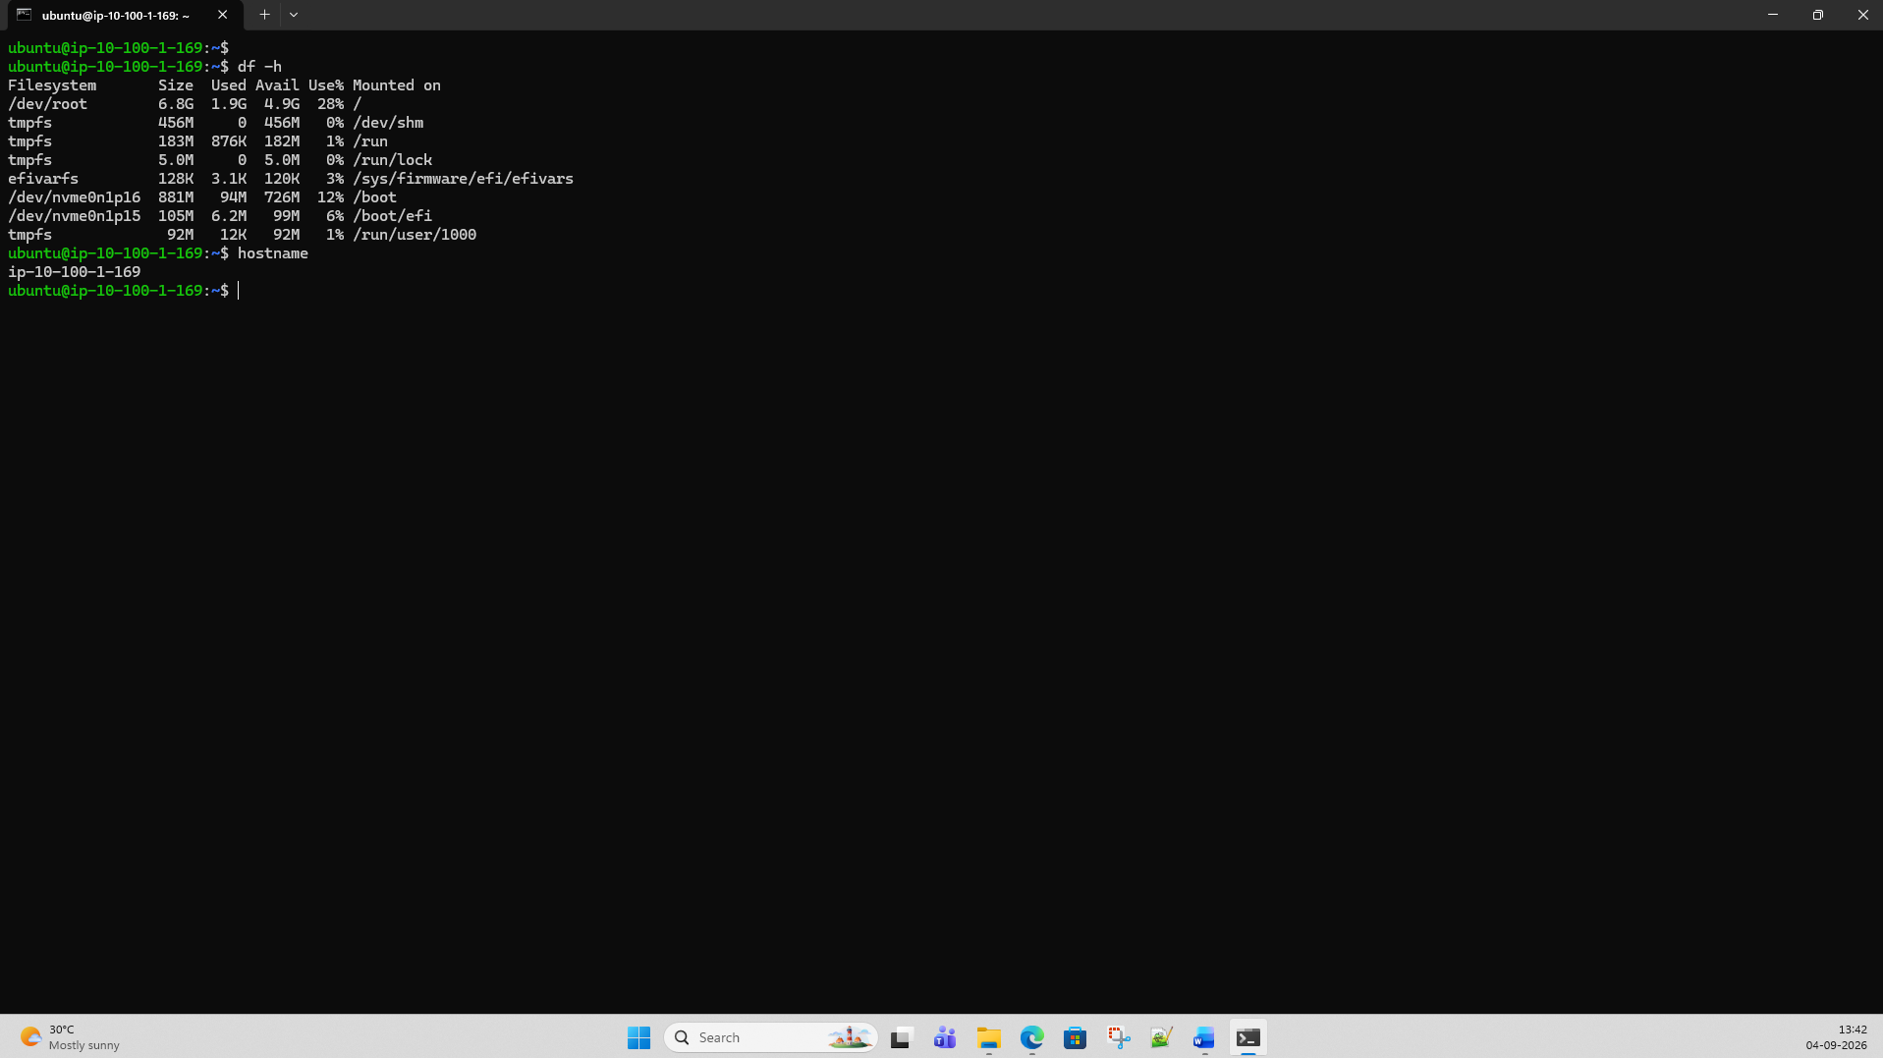

Step 12 — Now repeat everything for Region 2
Change the AWS Console Region to:
Asia Pacific (Singapore) — ap-southeast-1
Now create the exact same structure.
VPC-R2
Name: VPC-R2
CIDR: 10.100.0.0/16
Notice:
VPC-R1 = 10.100.0.0/16
VPC-R2 = 10.100.0.0/16
This is intentional.

R2 subnet
Create:
Name: R2-Public-Subnet
CIDR: 10.100.1.0/24
For example:
Singapore AZ: ap-southeast-1a

R2 Internet Gateway
Create:
IGW-R2
Attach it to:
VPC-R2

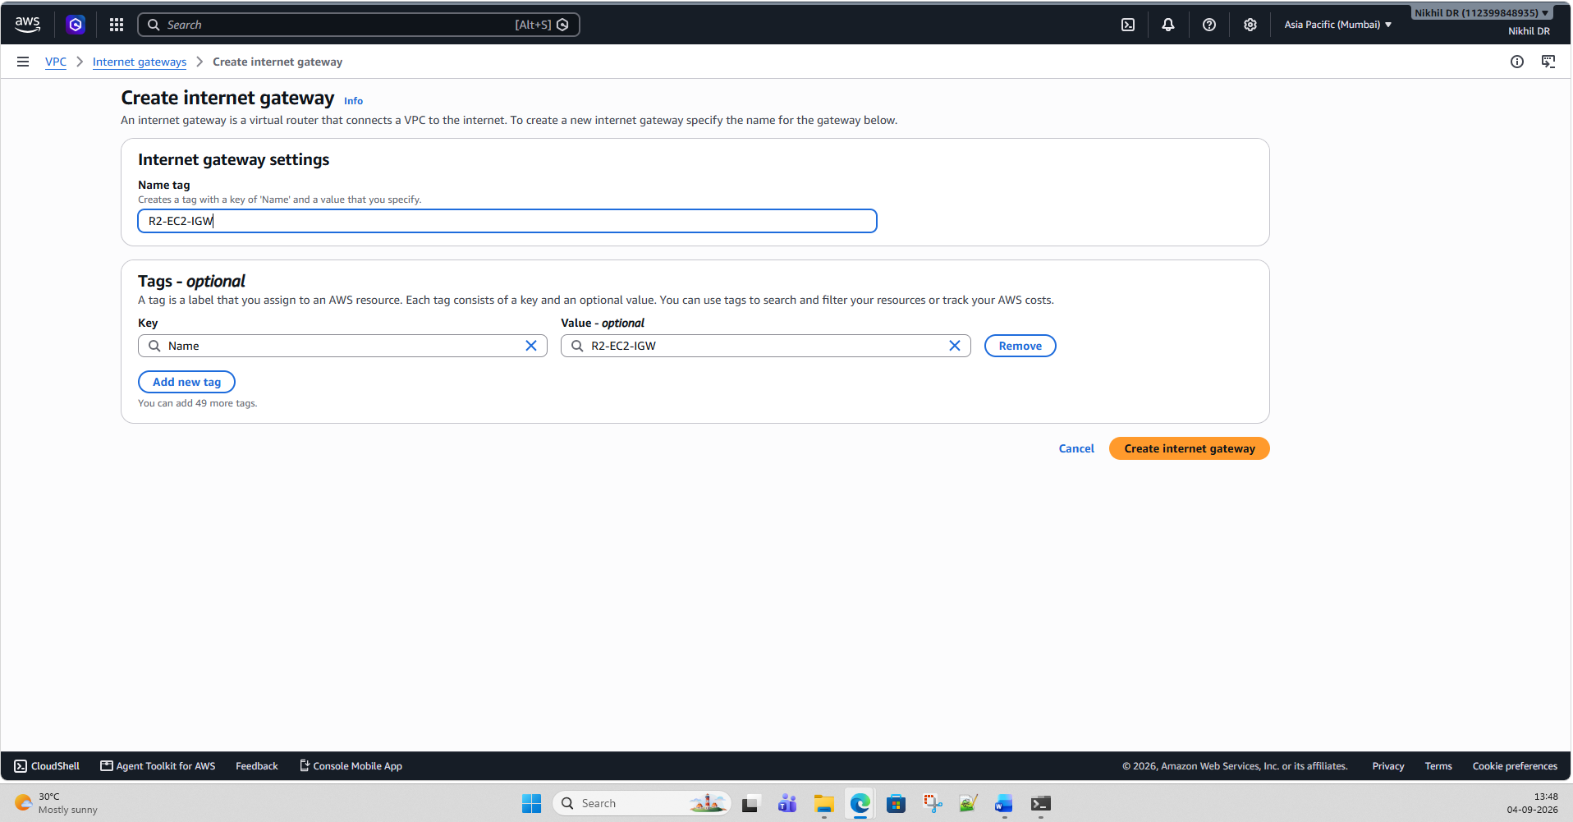

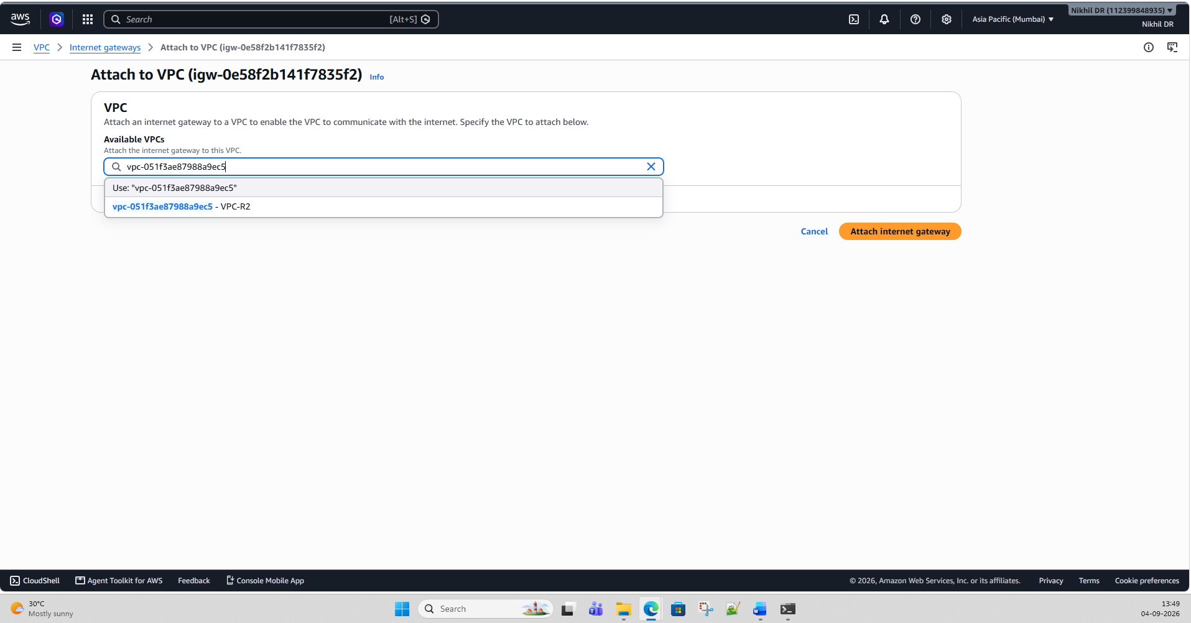

R2 Route Table
Create:
R2-Public-RT
Add:
10.100.0.0/16 → local
0.0.0.0/0 → IGW-R2
Associate it with:
R2-Public-Subnet

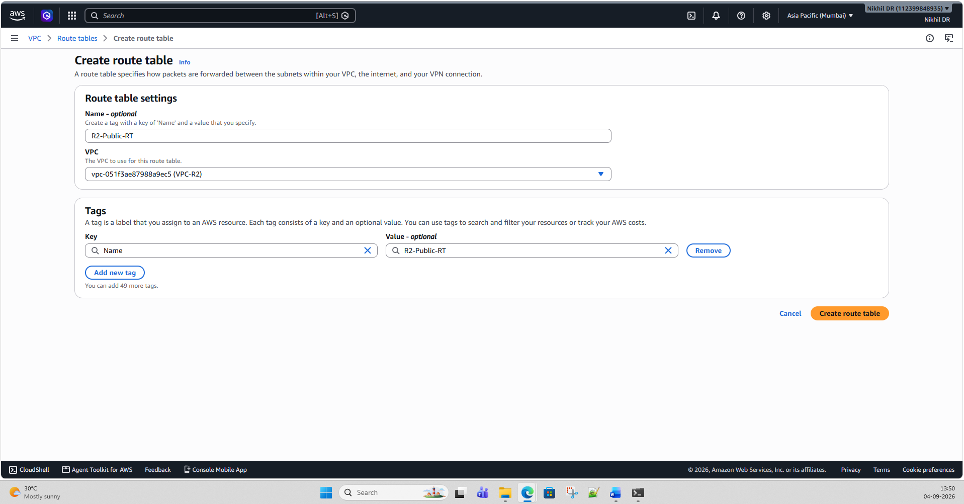
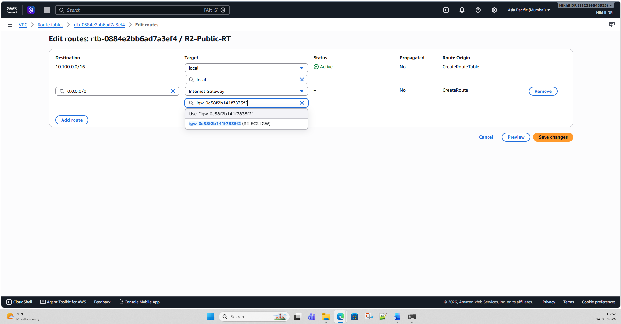

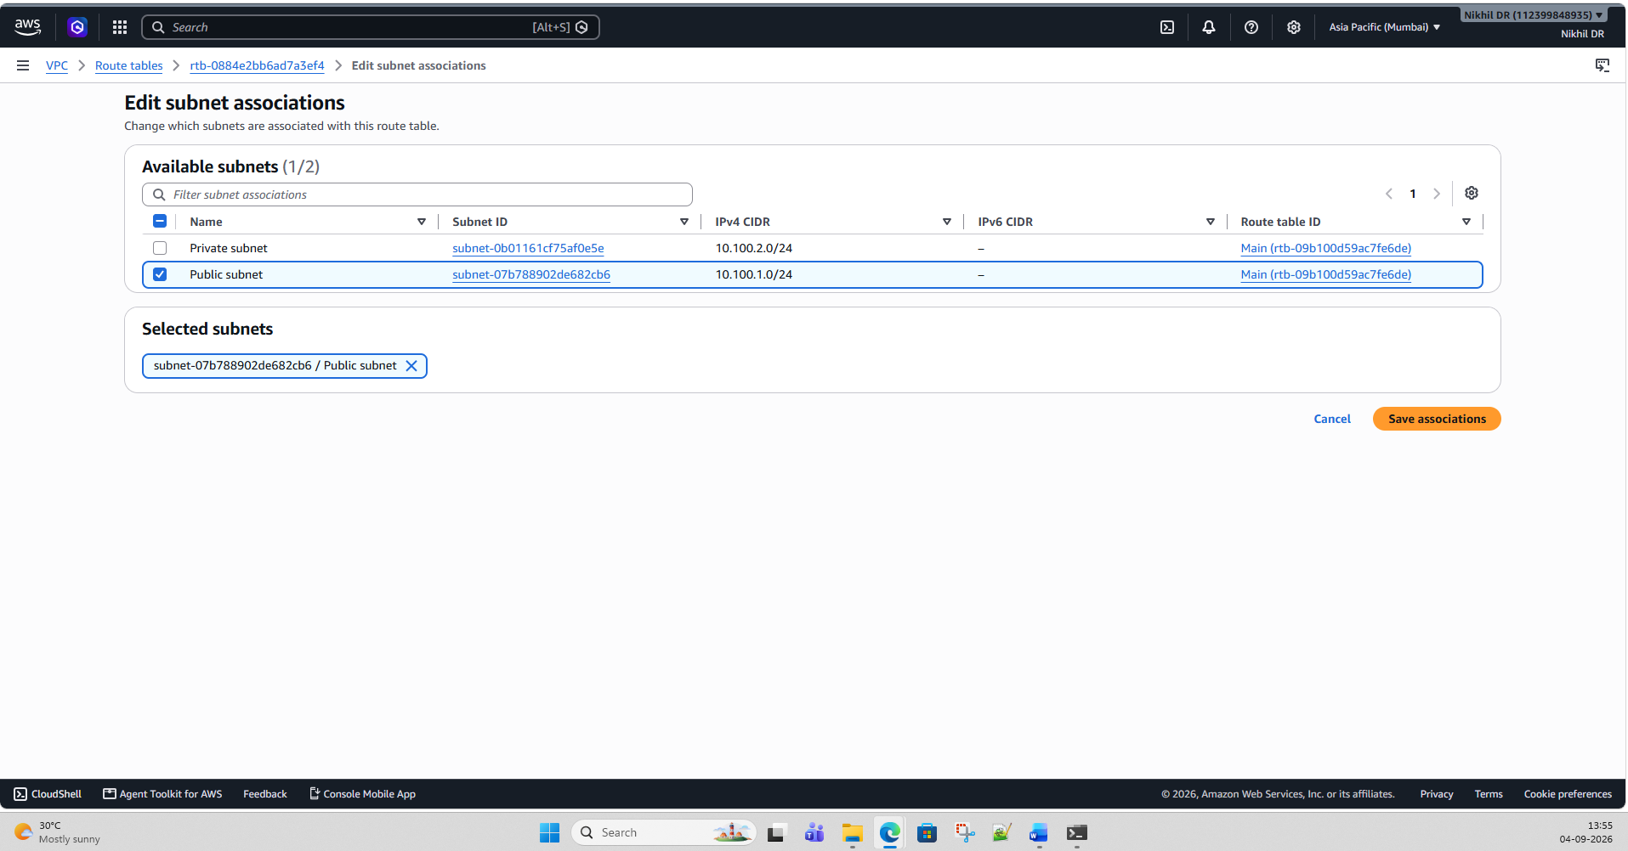
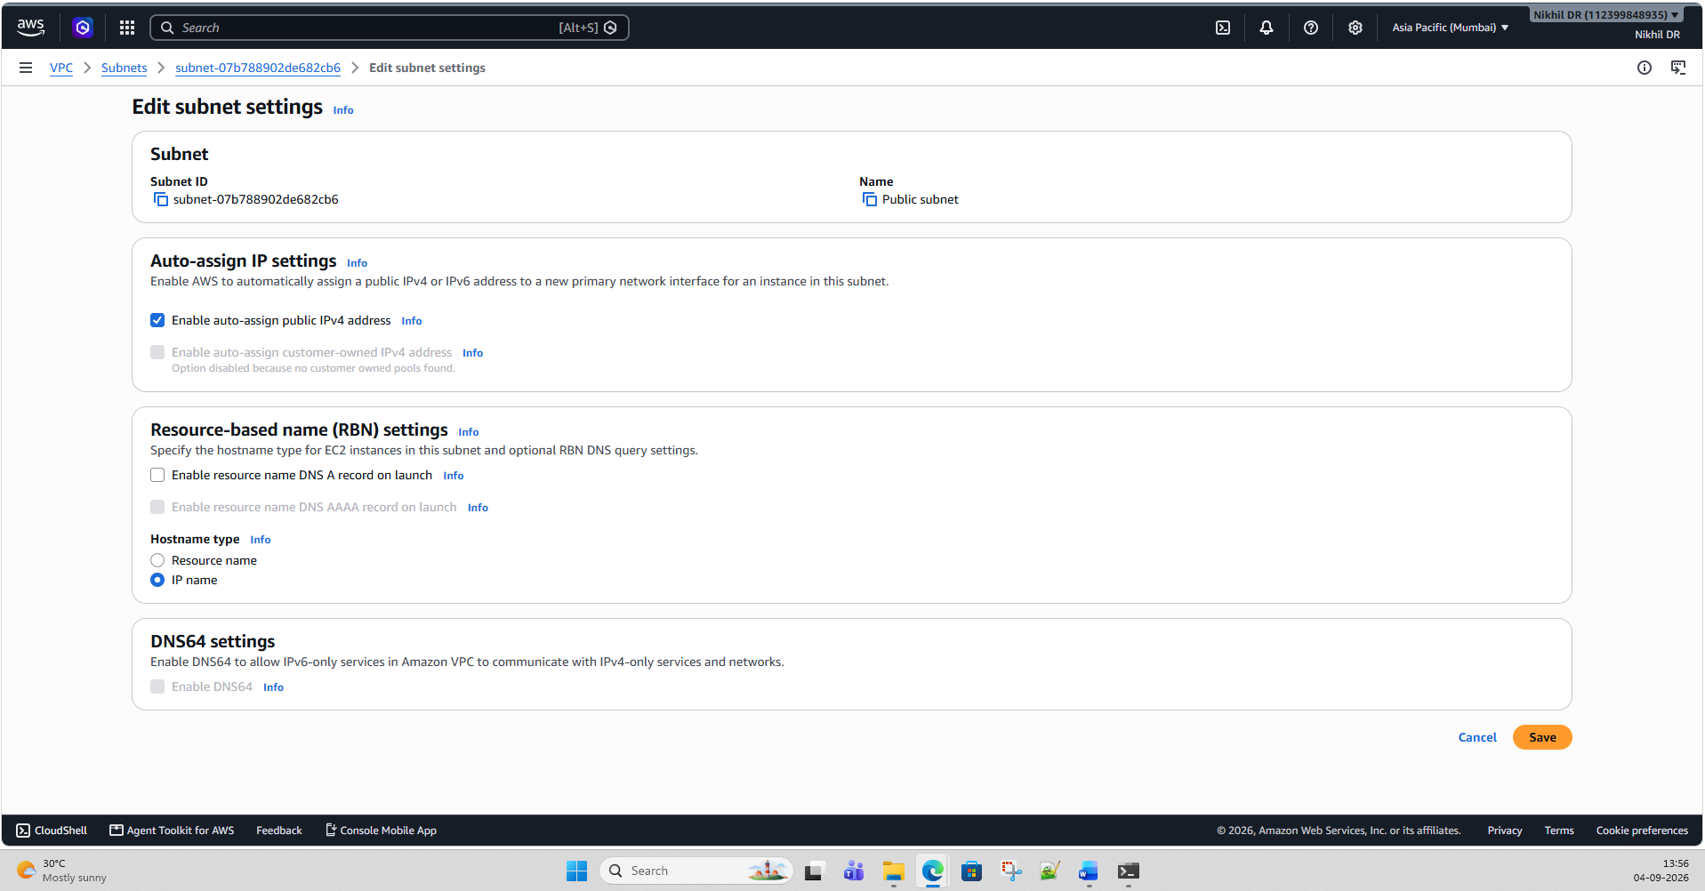

Step 13 — Create R2 Security Group
Create:
R2-EC2-SG
For SSH:
SSH
TCP
22
My IP
For temporary ping testing:
ICMP - IPv4 Echo Request
0.0.0.0/0

Step 14 — Launch EC2-R2
Launch another small Linux instance.
Configure:
Name:
EC2-R2

VPC:
VPC-R2

Subnet:
R2-Public-Subnet

Public IP:
Enabled

Security Group:
R2-EC2-SG
After launch, you'll have something like:
EC2-R1
Private IP: 10.100.1.25
Public IP: 13.x.x.x

EC2-R2
Private IP: 10.100.1.30
Public IP: 18.x.x.x
The actual IPs will differ.

Step 15 — Test R2 Internet
SSH into R2:
ssh -i your-key.pem ec2-user@<R2-PUBLIC-IP>
Then:
ping -c 4 8.8.8.8
and:
curl https://example.com
If successful:
R1 → Internet ✅
R2 → Internet ✅

Step 16 — Now test Region 1 → Region 2
This is where you should be careful about public vs private IP.
From EC2-R1:
ping <R2-PUBLIC-IP>
For example:
ping 18.x.x.x
Then:
ssh ec2-user@<R2-PUBLIC-IP>
If SSH is allowed from the R1 source IP, you can connect.
What are we testing here?
The traffic path is:
EC2-R1
|
| Public Internet
v
IGW-R1
|
v
Internet
|
v
IGW-R2
|
v
EC2-R2
This is NOT VPC-to-VPC private connectivity.
It's communication using the instances' public addresses over the Internet.

Step 17 — Very important test
Now try:
ping 10.100.1.30
from EC2-R1, assuming 10.100.1.30 is R2's private IP.
You should not expect this to reach EC2-R2.
Why?
Because from R1's perspective:
10.100.1.30
belongs to:
10.100.0.0/16
which is its own VPC's CIDR.
The R1 route table contains:
10.100.0.0/16 → local
Therefore, AWS treats that destination as local to R1 rather than something that should be sent to Region 2. AWS route selection uses the most specific matching route, and the VPC's local route covers the VPC CIDR. (AWS Documentation)
This is the key observation for your overall lab.

Your Phase 2 test results
You should end up with something like:
Test | Expected
R1 → Internet | ✅
R2 → Internet | ✅
R1 SSH using R2 public IP | ✅*
R1 ping R2 public IP | ✅*
R1 → R2 private IP | ❌
R2 → R1 private IP | ❌
VPC CIDRs | Same
VPC Peering | We'll test next
* depends on the security-group rules and whether the destination responds to the particular protocol.

Final topology
INTERNET
/ \
/ \
/ \
IGW-R1 IGW-R2
| |
| |
VPC-R1 VPC-R2
10.100.0.0/16 10.100.0.0/16
| |
Public Subnet Public Subnet
10.100.1.0/24 10.100.1.0/24
| |
EC2-R1 EC2-R2
10.100.1.x 10.100.1.x
| |
+------X---------+
Private
connectivity
doesn't
work
Next phase
Once you've completed this, Phase 3 should be VPC Peering. We'll attempt:
VPC-R1
10.100.0.0/16
|
| VPC Peering
|
VPC-R2
10.100.0.0/16
and I'll show you exactly where AWS rejects it because the CIDRs overlap, followed by the route-table and connectivity tests.

Phase 3 — Try VPC Peering
Create:
VPC-R1
10.100.0.0/16
|
| VPC Peering
|
VPC-R2
10.100.0.0/16
Expected result
AWS should reject the peering connection because the VPC CIDR blocks overlap.
This is actually one of the main tests we want from this lab.
You should document:
VPC-R1: 10.100.0.0/16
VPC-R2: 10.100.0.0/16

Result:
❌ VPC Peering cannot be established
Reason:
Overlapping CIDR blocks

Phase 4 — Test Transit Gateway
This is where the lab becomes more interesting.
Create:
AWS
|
-----------------------
| |
TGW Region 1 TGW Region 2
| |
VPC-R1 VPC-R2
10.100.0.0/16 10.100.0.0/16
For a cross-region Transit Gateway architecture, you can establish TGW peering between regional Transit Gateways.
However, the overlapping CIDRs still create a routing problem.
For example:
EC2-R1
10.100.1.10
|
| Destination 10.100.1.10
|
Route table
10.100.0.0/16 -> local
AWS sees 10.100.1.10 as belonging to the local VPC.
Therefore, traffic intended for the same address in Region 2 cannot simply be routed through the TGW.
Expected result
Same CIDR
↓
Overlapping routes
↓
❌ Direct private connectivity doesn't work

Phase 5 — Create the "real-world" scenario
This is probably the most valuable part of your lab.
Imagine:
Company A
AWS Account A
Region 1

VPC
10.100.0.0/16
Company B
AWS Account B
Region 2

VPC
10.100.0.0/16
You need to connect them.
This is common when:
- companies merge
- applications are acquired
- different business units use the same IP scheme
- on-premises networks overlap
- multiple AWS accounts were created independently

Phase 6 — Test NAT-based workaround
We can create a translated address space.
For example:
Actual VPC-R2:

10.100.0.0/16
But expose it to Region 1 as:
172.16.0.0/16
Conceptually:
Region 1 Region 2

10.100.1.10
|
|
| 172.16.x.x
|
v
Translation
|
v
10.100.1.10
This allows us to demonstrate address translation to solve overlapping networks.
For the lab, we can investigate an AWS-supported architecture using private NAT / NAT Gateway and routing, depending on exactly what traffic direction we want to test.

Phase 7 — Better solution: Renumber one VPC
Then create a second version of the lab.
Change Region 2 to:
VPC-R1
10.100.0.0/16

|
|
v

VPC-R2
10.200.0.0/16
Now:
10.100.0.0/16
|
VPC Peering
|
10.200.0.0/16
Expected result
✅ VPC Peering works.
Then test:
EC2-R1
10.100.1.10

|
| Private IP
|
v

EC2-R2
10.200.1.10
You can test with:
ping 10.200.1.10
and:
nc -zv 10.200.1.10 22

Recommended Lab Sequence
I'd build the lab in this order:
START
|
v
Create VPC-R1 10.100.0.0/16
|
v
Create VPC-R2 10.100.0.0/16
|
v
Deploy EC2s
|
v
Test Internet connectivity
|
v
Attempt VPC Peering
|
v
❌ Overlapping CIDR detected
|
v
Try Transit Gateway
|
v
❌ Routing conflict/overlap
|
v
Test NAT/translation approach
|
v
Change R2 CIDR to 10.200.0.0/16
|
v
Create VPC Peering
|
v
✅ Connectivity
|
v
END
Lab components
You don't need a large environment.
I'd recommend:
- 2 VPCs
- 2 AWS Regions
- 2 EC2 Linux instances — one per region
- 2 public subnets
- 2 private subnets (optional initially)
- Internet Gateway
- Route tables
- Security Groups
- VPC Peering
- Later: Transit Gateway
- Later: NAT-based solution
Cost-control recommendation
For the first experiment, don't create NAT Gateways or Transit Gateways immediately. They can incur charges.
Start with:
VPC → Subnet → EC2 → Internet Gateway → Peering test
Once that works, we can add the more advanced components.
If you want, I can next give you a click-by-click AWS Console lab, including the exact VPC/subnet CIDRs, route tables, security-group rules, EC2 configuration, and the exact commands to run from each Linux server.

Absolutely. Think of AWS Transit Gateway (TGW) as a central network hub/router that connects many VPCs and networks together.
1. What is Transit Gateway?
Normally, if you have multiple VPCs, you could connect them individually using VPC Peering.
For example:
VPC-A -------- VPC-B
|
|
VPC-C
If you have many VPCs, the number of connections becomes difficult to manage.
Transit Gateway changes this to a hub-and-spoke model:
VPC-A
|
|
VPC-B ------ Transit Gateway ------ VPC-C
|
|
VPC-D
The Transit Gateway acts like a central router.

2. Why do we need it?
Suppose your company has:
Production VPC
Development VPC
Testing VPC
Database VPC
Security VPC
Shared Services VPC
Without TGW, you might create many individual connections:
Production <--> Development
Production <--> Testing
Production <--> Database
Development <--> Testing
Development <--> Database
Testing <--> Database
...
This becomes difficult to maintain.
With Transit Gateway:
Production
|
Development ---- Transit Gateway ---- Database
|
Testing
|
Shared Services
Each VPC connects to the TGW, and routing is controlled centrally.

3. When should I use Transit Gateway?
Use TGW when you have many VPCs
For example:
10 VPCs
20 VPCs
50 VPCs
100+ VPCs
TGW becomes much more useful than managing lots of individual peering connections.

4. TGW is also useful for on-premises connectivity
This is an important real-world use case.
Suppose your company has:
AWS
|
Transit Gateway
/ | \
/ | \
VPC-1 VPC-2 VPC-3
|
|
VPN / Direct Connect
|
|
Corporate Network
Your corporate data center can connect to the Transit Gateway through:
- Site-to-Site VPN
- AWS Direct Connect
Then the TGW can provide connectivity to multiple VPCs.

5. Multi-region scenario
This relates directly to the lab you're building.
You can have:
Region 1
TGW-Region-1
|
+-----+-----+
| |
VPC-A VPC-B

||
TGW Peering
||

Region 2
TGW-Region-2
|
+-----+-----+
| |
VPC-C VPC-D
AWS supports Transit Gateway peering between Regions.
This is useful when you have many VPCs in multiple AWS Regions.

6. Transit Gateway vs VPC Peering
This is an important distinction.
Feature | VPC Peering | Transit Gateway
Connection model | Point-to-point | Hub-and-spoke
2 VPCs | Excellent | Usually unnecessary
Many VPCs | Becomes complex | Excellent
Central routing | Limited | Yes
Cross-region | Yes | Yes
On-premises VPN | Not directly as a central hub | Yes
Direct connection between VPCs | Yes | Via TGW
Centralized network management | Limited | Excellent
Simple rule
2–3 VPCs → VPC Peering may be enough.
Many VPCs → consider Transit Gateway.

7. Very important for your same-CIDR lab
Your original lab has:
Region 1
VPC-1
10.100.0.0/16

|
|
TGW
|
|
Region 2
VPC-2
10.100.0.0/16
You might think:
"If I use Transit Gateway instead of VPC Peering, will it solve my overlapping CIDR problem?"
No.
Transit Gateway is primarily a routing hub. It does not magically resolve overlapping IP addresses.
If both VPCs have:
10.100.0.0/16
then you have an address-space conflict.
For example:
VPC-1
10.100.1.10
|
| Destination: 10.100.1.10
|
v
TGW
|
?
|
VPC-2
10.100.1.10
Which 10.100.1.10 does the destination mean?
That's the fundamental problem.
So TGW ≠ solution for overlapping CIDRs by itself.

8. Easy way to remember
Think of the three technologies like this:
VPC Peering = Private road
VPC-A -------- VPC-B
A direct connection between two VPCs.
Transit Gateway = Highway interchange
VPC-A
|
VPC-B ---- [ TGW ] ---- VPC-C
|
VPC-D
Central place for routing between many networks.
VPN = Encrypted tunnel
Office ===== encrypted tunnel ===== AWS
And TGW can act as the central hub where multiple VPN/VPC connections meet.

For your AWS lab
I recommend we actually include TGW as Phase 2 so you can see the difference:
Lab 1: Same CIDR → try VPC Peering → see why it fails.
Lab 2: Same CIDR → try TGW → understand why overlapping CIDR is still a problem.
Lab 3: Change Region-2 to 10.200.0.0/16 → TGW → successfully communicate.
Lab 4: Explore how overlapping networks can be handled using NAT/address translation.
That sequence will give you a very practical understanding of Peering vs Transit Gateway vs overlapping CIDRs.

NAT = Network Address Translation.
In simple terms, NAT allows one IP address to be translated into another IP address while network traffic is passing through a router/firewall.
For your AWS lab, NAT is especially interesting because it can help when private servers need Internet access, and in some architectures it can help deal with overlapping network addresses.

1. Simple example
Imagine your home network:
Laptop
192.168.1.10
|
v
Router
|
v
Internet
Your laptop has a private IP:
192.168.1.10
But websites on the Internet cannot directly route to that private IP.
Your router performs NAT:
192.168.1.10
|
| NAT
v
Public IP
|
v
Internet
So NAT translates:
Private IP → Public IP

2. NAT in AWS
A very common AWS architecture is:
Internet
|
Internet Gateway
|
Public Subnet
|
NAT Gateway
|
Private Subnet
|
EC2
The EC2 instance is in a private subnet.
For example:
EC2
10.100.2.10
It needs to download updates from the Internet.
The route is:
EC2
10.100.2.10
|
v
NAT Gateway
|
v
Internet Gateway
|
v
Internet
The Internet sees the NAT Gateway's public address rather than the EC2's private address.

3. Why use NAT?
The most common reason is:
Private servers need outbound Internet access
For example, your private Linux server needs to:
- download OS updates
- download packages
- access AWS services
- retrieve software
- connect to external APIs
But you don't want the server to have a public IP.
So:
Private EC2
|
v
NAT Gateway
|
v
Internet
This is much safer than putting every server directly on the Internet.

4. NAT does NOT normally allow Internet → EC2
This is an important concept.
With:
EC2 → NAT Gateway → Internet
the EC2 can initiate outbound connections.
But an arbitrary Internet host cannot simply initiate a new connection back to that EC2 through the NAT Gateway.
So conceptually:
Private EC2 -----> Internet ✅
Internet ---------> Private EC2 ❌
This is one reason NAT is useful for private subnets.

5. NAT and your overlapping CIDR lab
Now we come to the interesting part.
Suppose:
Region 1 Region 2

VPC-A VPC-B
10.100.0.0/16 10.100.0.0/16

EC2-A EC2-B
10.100.1.10 10.100.1.10
Both EC2s have the same IP.
You cannot simply say:
10.100.1.10 → Region 2
because Region 1 also has:
10.100.1.10
This is an overlapping CIDR problem.
NAT/address translation can be part of a design where one side is represented using a different address space.
For example:
Region 1

10.100.1.10
|
| translated
v
172.16.1.10
|
v
Network
|
v
Region 2
So Region 1 might communicate with Region 2 using:
172.16.1.10
while the actual server remains:
10.100.1.10
This is called address translation.
However, it's important not to think of a standard AWS NAT Gateway as a magic solution for arbitrary VPC-to-VPC overlapping CIDRs. The exact architecture depends on the traffic direction and AWS networking components involved.

6. NAT Gateway vs NAT Instance
In AWS you'll commonly hear:
NAT Gateway
AWS-managed service:
Private Subnet
|
v
NAT Gateway
|
v
Internet Gateway
|
v
Internet
Advantages:
- AWS managed
- Highly available within an Availability Zone
- No OS to maintain
- Scales automatically
NAT Instance
You run your own EC2 instance configured to perform NAT:
Private Subnet
|
v
NAT EC2
|
v
Internet
You have to manage the instance yourself.
For most new AWS designs, NAT Gateway is preferred unless there is a specific reason to use a NAT instance.

7. NAT vs Internet Gateway
These are often confused.
Internet Gateway
Connects a VPC to the Internet.
VPC
|
Internet Gateway
|
Internet
NAT Gateway
Allows resources in a private subnet to initiate outbound Internet connections.
Private EC2
|
NAT Gateway
|
Internet Gateway
|
Internet
So they have different jobs.

8. NAT vs Proxy
Another useful distinction:
NAT works at the network/address level.
10.100.1.10
↓
translated address
A proxy acts as an intermediary for application traffic.
For example:
Application
|
v
HTTP Proxy
|
v
Website
So NAT isn't an HTTP proxy.

9. Real-world AWS example
Imagine:
AWS VPC
10.100.0.0/16
|
---------------------
| |
Public Subnet Private Subnet
| |
NAT Gateway Oracle DB
|
10.100.2.10
Your Oracle DB should not have a public IP.
But it might need to download updates or access an external service.
You can configure:
Oracle DB
10.100.2.10
|
v
NAT Gateway
|
v
Internet
The database remains private.

Easy way to remember
Technology | Think of it as
Internet Gateway | Door between VPC and Internet
NAT Gateway | Outbound translator for private resources
VPC Peering | Direct private connection between VPCs
Transit Gateway | Central router connecting many networks
VPN | Encrypted tunnel between networks
For your lab
I'd suggest we next build this topology:
REGION 1
VPC 10.100.0.0/16
|
EC2-1
10.100.1.10
|
X
VPC Peering fails
X
|
Transit Gateway
|
X
Overlapping CIDR
|
NAT/Translation
|
v
REGION 2
VPC 10.100.0.0/16
|
EC2-2
10.100.1.10
That would let you see exactly why overlapping CIDRs are a problem and what NAT can and cannot solve.

